Intermediate Deterministic Models In-Class Activity
DUE: with HW 4, one per student in hard-copy form – see HW 4 instructions

Multiperiod Transshipment Problem Python Implementation
- Write the formulation of the MPTP from the MPTP Day 1 handout in the general, abstract way shown in class using subscript identifiers and summation notation, not the specific terms expanded out with numeric values. This should only take a handful of lines.

- Pick a variable different from that of anyone you are working with. Write down its name/label. Explain specifically what physical aspect of the problem it represents.

- Is the model as implemented in the code treating the problem as balanced or unbalanced? Explain.

Next refer to the following Python and data files in the LEC\lec07-08-transshipment-problem\code-data folder of the IDM course repo:

- mp_tranship.py
- mptp_data_01.dat
- arc.py
- node.py

If a question is a task not requiring a written response, put a check mark or your initials next to it to signify you completed it.
- Run the node.py file. Create a Node object in the console. Write down what you typed in the console to successfully create a Node object.

- Run the arc.py file. Create an Arc object in the console. Write down what you typed in the console to successfully create an Arc object. Hint: you should create two node objects first.

- Look at the code in mp_tranship.py and figure out where to put the dat file and the two class files relative to mp_tranship.py. Make sure you put the files in the right places for you to run the code.

- Run mp_tranship.py. It should work and produce a solution. What is the objective value?

- The table below lists some of the important data structures used in the code. Fill in the blank cells. An example row is completed for you.
Data structure | Data type | Contents  (e.g., items if it is a list, keys/values if it is a dict, etc.) | Data type of contents | How it is used later in the code and/or LP
node_objects | dict | Node objects  Keys are tuples identifying the node. Values are the Node objects. | Node objects | Used for creating arc objects, dummy nodes, inventory arcs, and flow balance constraints
data
_arc_list attribute of a Node object
arc_capac
arc_costs
lead_times
Data structure | Data type | Contents | Data type of contents | How it is used later in the code and/or LP
node_names
path_node_labels
path_arc_labels
arc_objects
x
arcs_in

- What is created by the following line of code:

node_objects[node_label] = Node(locn, wk, supply_amt,demand_amt)

- What does max_dem_wk represent and why is it used?

- In class we established that a week-5 Norfolk node was not needed. The code determines this as well. How does the code accomplish this?

- After node_objects is created in Part III, it is modified later in Part IV. Explain why? What is the modification?

- What specific information about the arc does each arc object contain? (Arc objects are found in the dictionary arc_objects.)

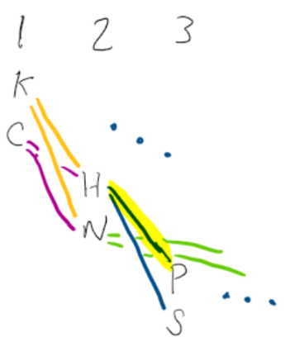
- Consider the arc H2,P3 in the diagram (labeled HOU_2,PAN_3 in the code). List the model parameters and model variable(s) associated with this arc (in words or symbols) and the Python variable name storing each one (if it is a dictionary, specify the key). Use the table below.

Name or description of the model parameter or variable (e.g. arc capacity) | Corresponding Python variable
- Looking over the completed code, roughly estimate the percentage of the code that creates the LP (as opposed the code used to set up the data structures to be used by the LP formulation).

- Looking over the code, pick a portion that does not immediately make sense to you, different from that of anyone you are working with. Spend some time trying to understand it. Indicate the portion of code and what it does as your answer.

- Run mp_tranship.py again to produce a solution and answer the following questions about the solution:
  - Are more units transported through Houston or Norfolk, or is the amount the same? Provide totals for each to justify your answer.

  - Was inventory held at any location(s)? Where, when and how much?

- Make the following change to the dat file and rerun the code. For your answer to this question, attach the output showing the LP solution results.
Add an additional transshipment node - Jacksonville (‘JAX’) - to the problem network. Assume costs of 41, 42, 32, and 5 on arcs between it and 'KCI', 'CHI', 'PAN', and 'SJU', respectively. Assume lead times of 1, 2, 1, and 1 on arcs between it and 'KCI', 'CHI', 'PAN', and 'SJU', respectively. Re-solve the LP.

- Starting with the original dat file - not the one from the previous question - revise the code and dat file to handle variable arc capacity. You may want to mimic the way arc_costs and arc_times are handled both in the dat file and near the top of the py file.
  - Test this out by setting all arc capacities to 300 in the dat file and confirming you obtain the same solution as before this change.
  - Change the capacity of the NRF-SJU arc to 150 (from 300). You should obtain a feasible solution. Attach the full solution as your answer to the problem.

